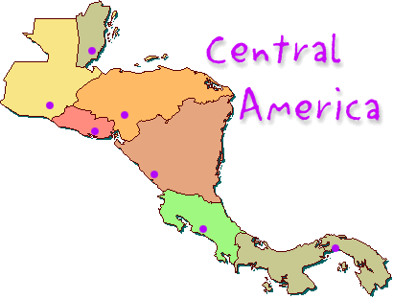
Chapter 7 Section 1 & 2
Page 199-203
Physical Geography of Central America
Vocabulary  Isthmus – a strip of land that connects 2 land masses  Highlands – mountainous or hilly sections of a country  Tectonic Plate – a large rigid section of the Earth’s crust that is in constant motion. | Physical Description & Landforms  Central America is located on an isthmus between North and South America. It is mostly composed of highlands. It also lies at the edge of 2 tectonic plates so, earthquakes occur often.
Climate & Vegetation  Central America has a tropical climate. The plains on the Caribbean (eastern) side receive the most rainfall and the climate promotes the growth of lush rainforests. Temperatures are cooler at higher elevations. At higher elevations are forest of pine and oak. Along the Pacific (western) side you can find desert shrub. | Water Resources  The eastern side of the isthmus receives lots of rainfall while the western side receives little rainfall.

Summary:___________________________________________________________________________________________________________________________________________________________________________________________________________________________________________________________________________________________________________________________________________________________________________________________________________________________

