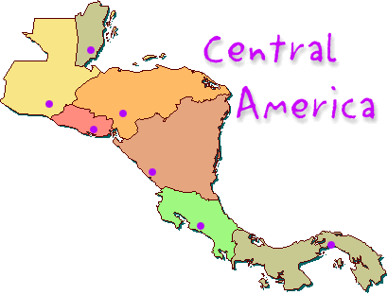
Chapter 7 Section 1 & 2
Page 199-203
Physical Geography of Central America
Vocabulary | Physical Description & Landforms
Climate & Vegetation | Water Resources

Summary:___________________________________________________________________________________________________________________________________________________________________________________________________________________________________________________________________________________________________________________________________________________________________________________________________________________________

