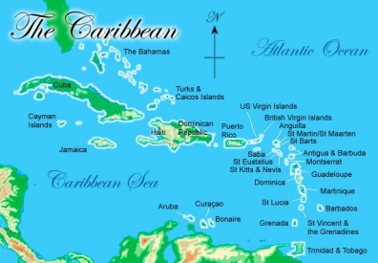
Chapter 7 Section 1 & 2
Page 199-203
Physical Geography of Caribbean Islands
Vocabulary  Archipelago – a chain of islands  Greater Antilles – the northern largest Caribbean islands, Cuba, Jamaica, Hispaniola (Haiti and the Dominican Republic), and Puerto Rico  Lesser Antilles – the smaller Caribbean islands southeast of the Greater Antilles | Physical Description & Landforms  Most of these islands are actually the exposed tops of underwater mountains. Mountains and highlands make up the interior of most islands, while plains circle the highlands.
Climate & Vegetation  The climate is warm year round. Winds bring warm moist air over the islands. Areas that face the wind receive more rainfall, and protected areas receive less rain. The allows for diverse vegetation including rainforests, deciduous forests, and deserts. | Water Resources  Rain is the primary source of water. Rain is caused when warm moist air is forced up by mountains and highlands. This causes the temperature to drop, which allows the moisture to condense and fall as rain. Areas that face the wind receive more rainfall, and protected areas receive less rain.

Summary:___________________________________________________________________________________________________________________________________________________________________________________________________________________________________________________________________________________________________________________________________________________________________________________________________________________________

